**T.Y.BSc(I.T) SEM-VI Maharashtra College Advanced Mobile Programming**



Practical 4

Programs related to different Layouts Linear, Relative, Table.

# Linear Layout in Android

LinearLayout is a ViewGroup that is responsible for holding views in it. It is a layout that arranges its children i.e the various views and layouts linearly (one after another) in a single column(vertically) or a single row(horizontally).

# Horizontal LinearLayout

In a horizontal LinearLayout, as the name suggests, the Views defined inside the Linear Layout will be arranged horizontally one after another, like in a row. By default, the orientation is set to horizontal.

But its a good practice to explicitly specify the orientation of the linear layout by setting the attribute android:orientation with value horizontal in the LinearLayout tag.

# Vertical Linear Layout

In a vertical LinearLayout, as the name suggests, the Views defined inside the Linear Layout are arranged verically one after another, like in a column. And for this we need to mention

the android:orientation attribute with value vertical within the LinearLayout tag.

**Activity_main.xml**

*<?***xml version="1.0" encoding="utf-8"***?>*

<**LinearLayout xmlns:android=**[**"http://schemas.android.com/apk/res/android**](http://schemas.android.com/apk/res/android)**" xmlns:app="**[**http://schemas.android.com/apk/res-auto"**](http://schemas.android.com/apk/res-auto) **xmlns:tools="**[**http://schemas.android.com/tools**](http://schemas.android.com/tools)**" android:layout_width="match_parent" android:layout_height="match_parent"**

**android:orientation="vertical" tools:context=".MainActivity"**>

<**EditText android:id="@+id/editText"**

**android:layout_width="wrap_content" android:layout_height="86dp" android:layout_weight="1" android:ems="10" android:hint="Enter The Text" android:inputType="textPersonName" android:text="Type Here" android:textColor="#FFEB3B"** />

Remember

If you want horizontal layout just change orientation to horizontal

**android:orientation="horizontal"**

**T.Y.BSc(I.T) SEM-VI Maharashtra College Advanced Mobile Programming**

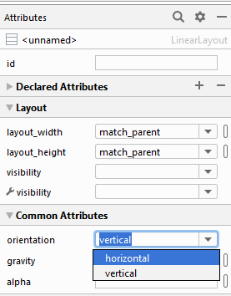

<**Button android:id="@+id/button"**

**android:layout_width="wrap_content" android:layout_height="wrap_content" android:layout_weight="1" android:text="Button"** />

<**TextView android:id="@+id/textView2" android:layout_width="wrap_content"**

**android:layout_height="wrap_content" android:layout_weight="1" android:text="TextView"** />

<**TextView android:id="@+id/textView3" android:layout_width="wrap_content"**

**android:layout_height="wrap_content" android:layout_weight="1" android:text="TextView"** />

<**TextView android:id="@+id/textView4" android:layout_width="wrap_content"**

**android:layout_height="wrap_content" android:layout_weight="1" android:text="TextView"** />

</**LinearLayout**>

You can also change the orientation using attribute window as

Note : Here We are getting background as black because we set the background color in style.xml in previous practical

<**item name="android:background"**>#000000</**item**>

<**item name="android:textColor"**>#FFFFAA</**item**>

**T.Y.BSc(I.T) SEM-VI Maharashtra College Advanced Mobile Programming**



Output:

|  |  |
| --- | --- |
| Horizontal LinearLayout | Vertical LinearLayout |

* + 1. **Sc(I.T) SEM-VI Maharashtra College Advanced Mobile Programming**



# Relative Layout

* + - * [RelativeLayout](https://developer.android.com/reference/android/widget/RelativeLayout.html) is a view group that displays child views in relative positions. The position of each view can be specified as relative to sibling elements (such as to the left-of or below another view) or in positions relative to the parent [RelativeLayout](https://developer.android.com/reference/android/widget/RelativeLayout.html) area (such as aligned to the bottom, left or center).
      * A [RelativeLayout](https://developer.android.com/reference/android/widget/RelativeLayout.html) is a very powerful utility for designing a user interface because it can eliminate nested view groups and keep your layout hierarchy flat, which improves performance. If you find yourself using several nested [LinearLayout](https://developer.android.com/reference/android/widget/LinearLayout.html) groups, you may be able to replace them with a single [RelativeLayout](https://developer.android.com/reference/android/widget/RelativeLayout.html).

## Activity_main.xml

|  |  |  |
| --- | --- | --- |
|  | Remember |  |
| *<?***xml version="1.0" encoding="utf-8"***?>* |  |
| <**RelativeLayout xmlns:android=**[**"http://schemas.android.com/apk/res/android**](http://schemas.android.com/apk/res/android)**" xmlns:app="**[**http://schemas.android.com/apk/res-auto"**](http://schemas.android.com/apk/res-auto) **xmlns:tools="**[**http://schemas.android.com/tools**](http://schemas.android.com/tools)**" android:layout_width="match_parent" android:layout_height="match_parent"**  **android:orientation="vertical" tools:context=".MainActivity"**>  <**EditText android:id="@+id/name"**  **android:layout_width="match_parent" android:layout_height="wrap_content" android:hint="Enter Text Here"** />  <**Spinner android:id="@+id/dates" android:layout_width="0dp"**  **android:layout_height="wrap_content" android:layout_below="@id/name" android:layout_alignParentLeft="true" android:layout_toLeftOf="@+id/times"** />  <**Spinner android:id="@id/times" android:layout_width="96dp"**  **android:layout_height="wrap_content" android:layout_below="@id/name" android:layout_alignParentRight="true"** />  <**Button android:layout_width="96dp"**  **android:layout_height="wrap_content" android:layout_below="@id/times"**  **android:layout_alignParentRight="true" android:text="Click Here"** /> | | |

**T.Y.BSc(I.T) SEM-VI Maharashtra College Advanced Mobile Programming**



## </RelativeLayout>

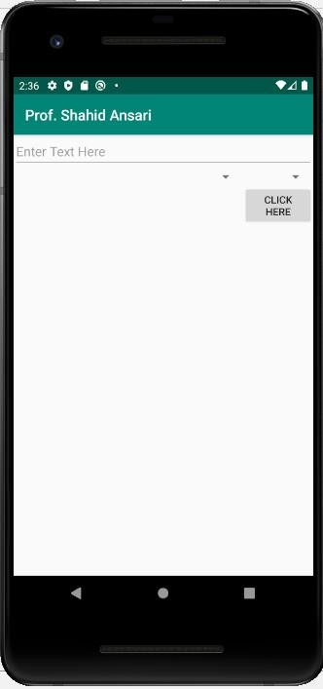

**T.Y.BSc(I.T) SEM-VI Maharashtra College Advanced Mobile Programming**



# Table Layout

Android TableLayout going to be arranged groups of views into rows and columns. You will use the

<TableRow> element to build a row in the table. Each row has zero or more cells; each cell can hold one View object.

TableLayout containers do not display border lines for their rows, columns, or cells. The table will have as many columns as the row with the most cells. A table can leave cells empty. Cells can span multiple columns, as they can in HTML. You can span columns by using the span field in

the [TableRow.LayoutParams](https://developer.android.com/reference/android/widget/TableRow.LayoutParams.html) class.

**Main_activity.xml**

*<?***xml version="1.0" encoding="utf-8"***?>*

<**TableLayout xmlns:android=**[**"http://schemas.android.com/apk/res/android**](http://schemas.android.com/apk/res/android)**" android:layout_width="match_parent" android:layout_height="match_parent"**

**android:stretchColumns="1"**>

<**TableRow**>

<**TextView android:layout_width="225dp" android:layout_height="56dp" android:padding="3dip" android:text="Row1,Col1"** />

<**TextView android:layout_height="match_parent" android:gravity="right" android:padding="3dip" android:text="Row1,Col2"** />

</**TableRow**>

<**TableRow**>

<**TextView android:layout_width="242dp" android:layout_height="64dp" android:padding="3dip" android:text="Row2,Col1"** />

<**TextView android:layout_height="match_parent" android:gravity="right" android:padding="3dip" android:text="Row2,Col2"** />

Remember

**T.Y.BSc(I.T) SEM-VI Maharashtra College Advanced Mobile Programming**



</**TableRow**>

</**TableLayout**>

